## DB Conversion Process

## Decrypting/Preparing the DB

Generate a mobile installation kit. This is when the decryption of the quantities happens. The process may take 6 hours.

## Generating the CSV files

Notes:

1. Make sure the **export_to_csv** object is created in the access db.
2. Make sure the "**MyExportSpecif**" is created on "**alfa_romeo**" table or similar.

To do so: right click “alfa_romeo” table🡺

export🡺

text file 🡺

(do not check any checkbox) ok🡺

next….🡺

before finish click advanced🡺

**Make sure to choose UTF-8 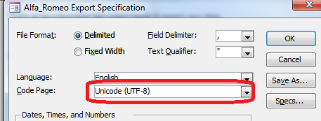**🡺

save as🡺type”**MyExportSpecif”🡺ok🡺finnish🡺close**

Run the procedure “Export_to_csv” as follow:

* Open the database file “dbPaintShop.mdb”.
* Double click “Export_to_csv”:

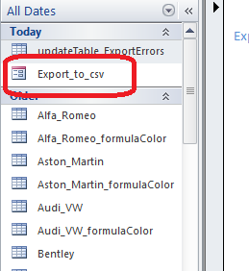

* Click the button:

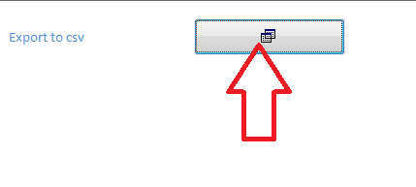

* Wait for the process:

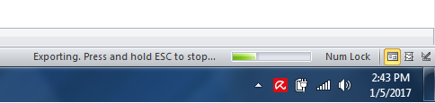

* The folder “csv” will be created if not exist, if the folder already existed it will be replaced with the new one:

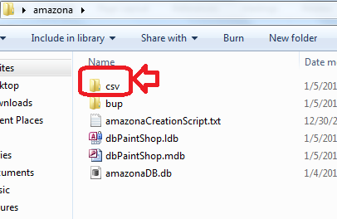

* Delete the exisiting “amazonaDB.db” file if it exists next to the access DB in play

## Creating the SQLite Database

* Open a “cmd” prompt:

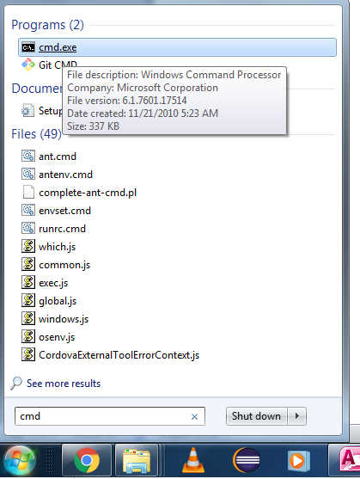

* Go to the location of the working database:

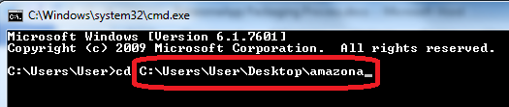

* *cd C:\Users\User\Desktop\amazona*

*(In this example my dbPaintShop.mdb exists in C:\Users\User\Desktop\amazona)*

* type: sqlite3 then enter:

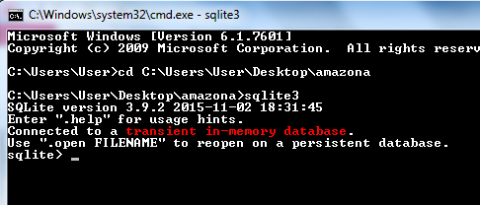

* Copy/Paste the content of the file “amazonaCreationScript.txt”
* Now the sqlite db is created and nourished
* Update the “logo” column in the garage table et set the chosen field to ‘0’, with the same values of the old DB. Use the **“fixLogosANDsetChosen.sql”** script.
* Modify the “**appSync.sql**”, then run it**:**
  + **theVersion**: should be the current version. Logically it is plus one version after the last one in <https://www.amazonapaints.com/testftp/dbSync.txt>
  + **stopSyncIndex**: put it to the value of <http://www.amazonapaints.com/testftp/stopSync.txt> **+ 1**, because when resetting from the HQ, the stopSync.txt value will be incremented by 1 (so the app in the market be obliged to update from the store) therefore this new app release won’t be obliged to update from the store because it is the last update.
  + **forceSync**: should be kept “0”, this value is edited by the app, as flag to set controlling if this app must be synced before use.
* Close the database and save.
* After the DB is created. copy/paste it in "C:\hybridworkspaces\amazonaApp\www

And under the build folder also (search for it).